Bearsden Academy Maths Dept. SQA Maths Exams
‘How do I study Maths??’

Studying maths is the same (but different) from studying other subjects!
Some people
• see things, methods, formulae in pictures
• see and remember them in symbols
• see the connection between things in spider diagrams, mind maps

YOU will have an idea of the styles of learning you feel comfortable with and the table on Page 3 gives ways you can use these styles to help you study maths. For all students of maths the benefits of remembering some formulae or key words or key methods are huge. The confidence you gain by knowing where a test question is going means you can cope
• if something goes slightly wrong or
• if you don’t see immediately what the next part of the problem is
about
because you will be prepared to try something rather than giving up. Remember school maths exams are based on the topics you study in class
– a problem in an exam which you can’t follow will be based on work you
have studied, this year or in previous years, with your teacher.

You can’t study maths just by reading about it – you have to do a mix of reading about the facts, methods, applications of the topic
• from the Notes folders on your CD (S4, 5 ,6)
• from the Recap page in each chapter of your textbook
and doing examples
• from the Practice sheets on your CD (S4, 5 ,6)
• from the Revise page in each chapter of your textbook
• from your SQA past papers (S4, 5 ,6)
The ‘Study Circle’ on Page 4 shows how to do this using your text- book/homework booklet.

Here is one possible revision route:
• choose a topic e.g. TRIG
• read through any relevant notes & examples, looking for formulae &
techniques you need to know
• remember them in a way that suits you (see Page 3 )
• attempt some relevant examples, correcting each as you go
• if you don’t get the correct answer DON’T move on until you understand where you made the mistake
• if you can’t pinpoint the difficulty, ask your teacher, a friend,
someone in the family but don’t leave it too late!
• attempt some Past Paper questions without using your notes

Web-based Help
There is a useful page on the SQA website with advice on Study Skills. This link will take you to it
http://www.sqa.org.uk/sqa/13853.html
The Skills on the link which are particularly useful in Maths are ‘Study
Techniques’ and ‘Time Management’.
Learning Teaching Scotland also has useful study help at http://www.ltscotland.org.uk/studyskills/15to18/index.asp

Maths sites which are useful are
http://www.bbc.co.uk/scotland/education/bitesize/index.shtml
http://www.s-cool.co.uk/default.asp

On Exam day
Before
• get your equipment ready in advance
• arrive in plenty of time and don’t forget breakfast
During
• read all questions carefully
• look for clues in questions o is there a triangle? o is it right-angled?
o is it a Pythagoras or SOHCAHTOA question?
o Make sure you work with correct units
. show your working clearly – diagrams are helpful

TRY YOUR BEST – it really is worth it and, if you do, you can be proud of your achievements.

• spoken word
• lectures
• discussions
• audio tapes
• written word
• diagrams/pictures
• films/TV/videos
• wall charts

Kinaesthetic- learning involves:

• movement/acting
• hands on activities
• design/drawing
• writing
• practising the skill while receiving instructions

Which styles of learning help you?

Visual Learning | Auditory Learning | Kinaesthetic Learning
Rewrite your notes as mind-maps | Read your notes to yourself | Copy out your notes. Write down from memory key points
Use colour to highlight points | Read your notes silently. Learn to 'self- talk' | Move around the room when you are revising
Draw diagrams and sketches to help you remember points | Record yourself reading key points - use later when out for a jog/walk | Revise while you do exercise - literally 'jog' your memory
Rewrite your key points using different words | Revise with friends or a  'study buddy' | Mentally review what you have been revising
Use computer revision programmes | Make up notes to a favourite tune | Place key points about your room/home on post-its.

2. Revise

Revise section
- End of Chapter

C\l

Evaluate your weakness -
Try mixed examples at of book

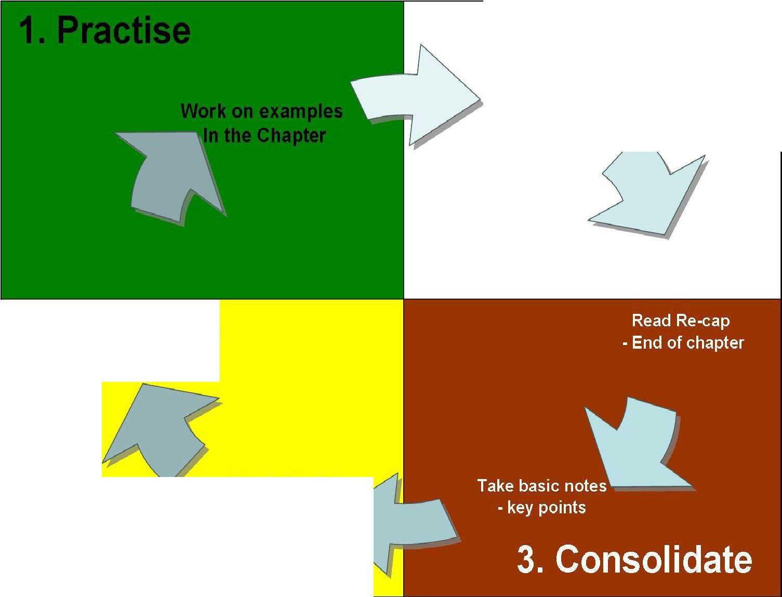
4. Assess & Evaluate

